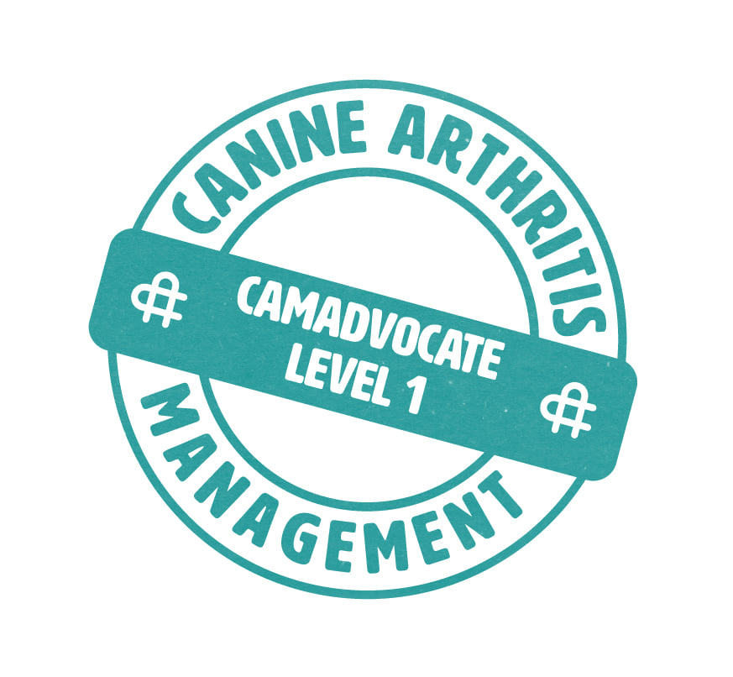
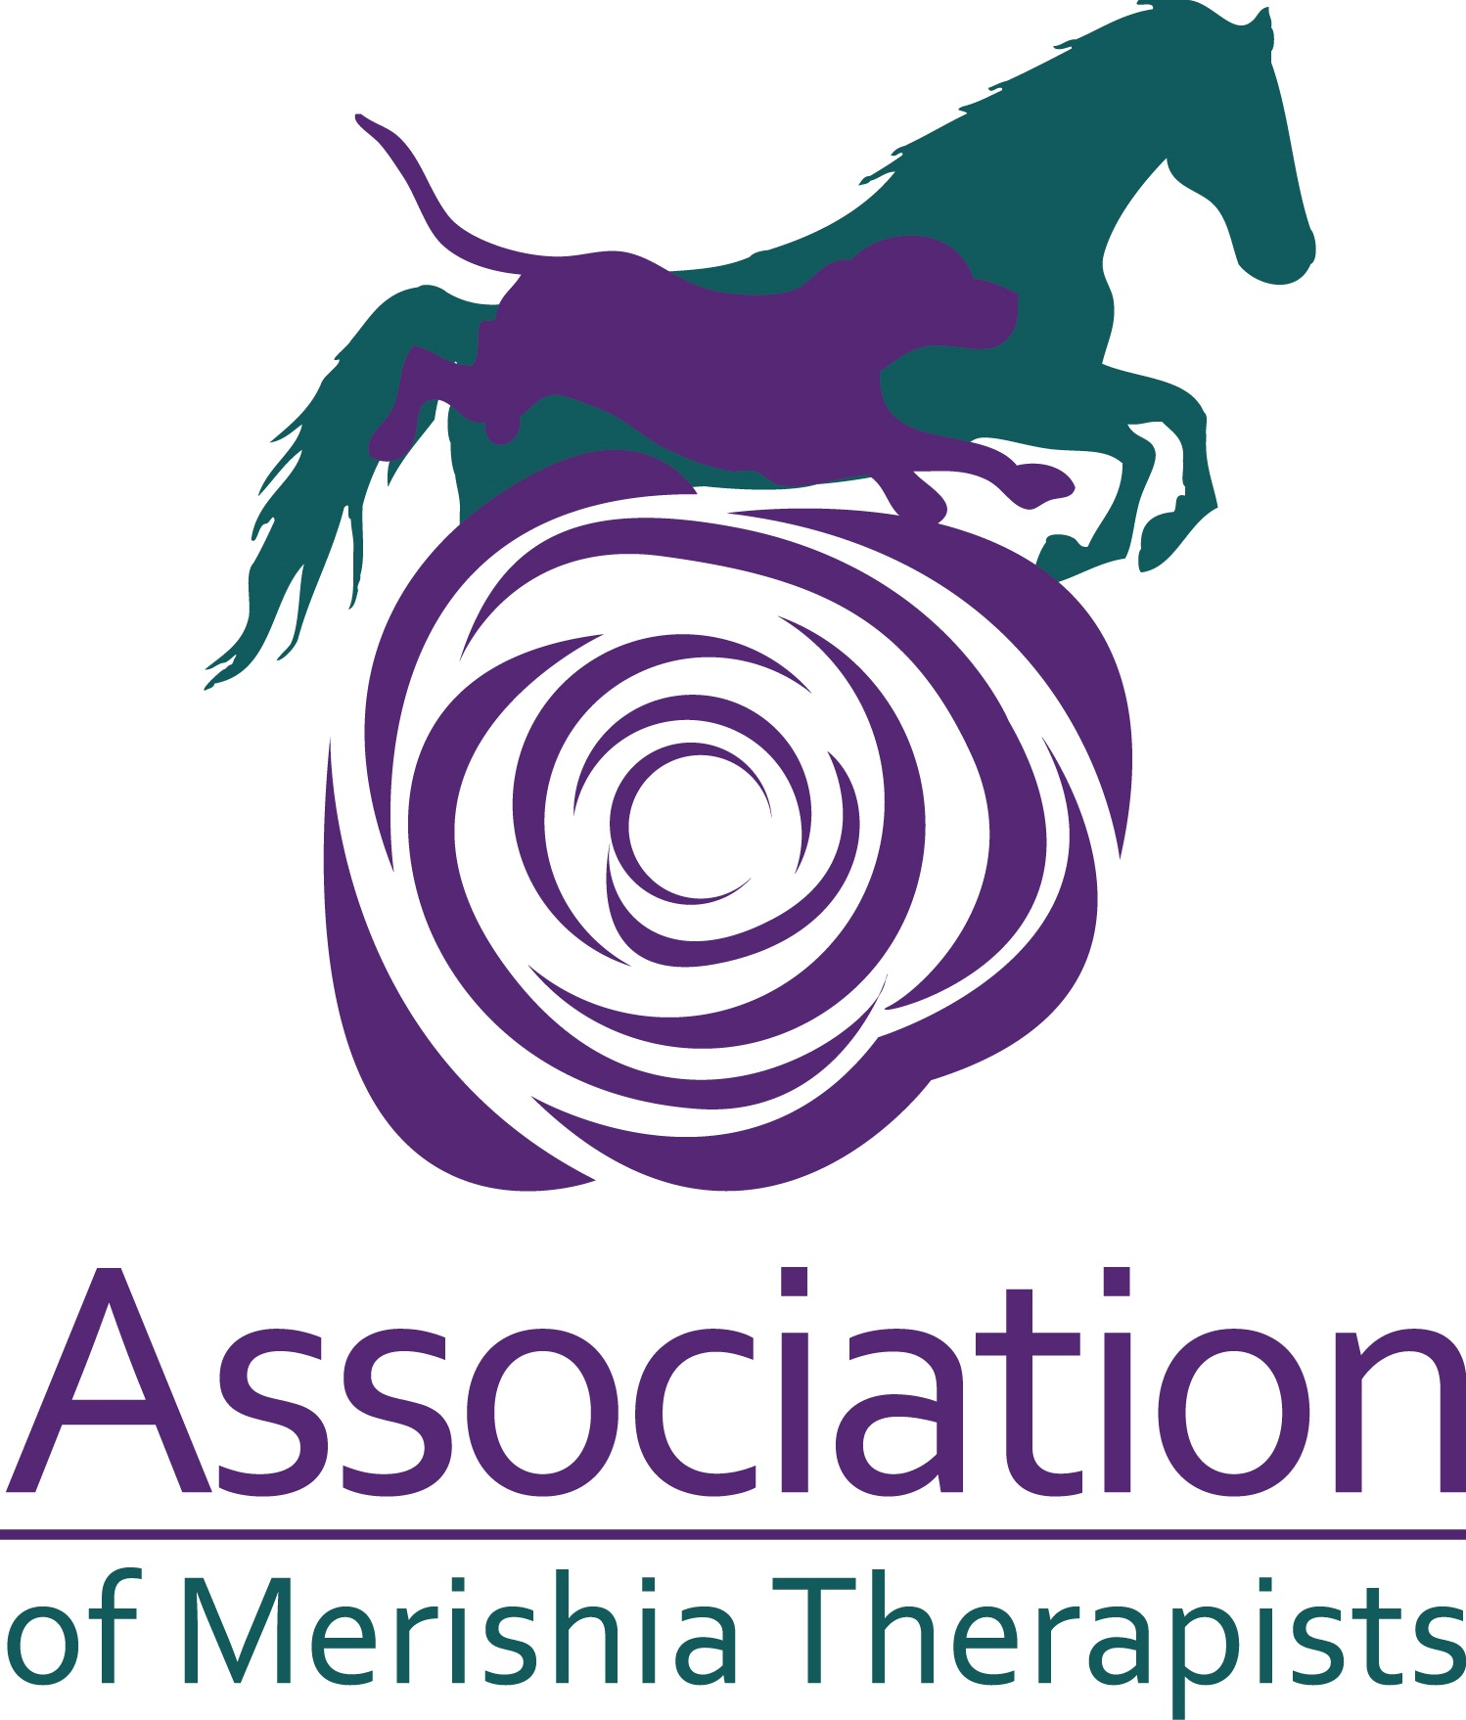
Kirstey Lee Cardiff Canine Massage
07943765736 kirstey.lee@outlook.com

Owner’s Name
Address

Telephone No.
Mobile No.
E Mail
Post Code:

Dog’s Details
Name |  | Breed |  | Sex:
D.O.B |  | Colour |  | Neutered?
Reason For Treatment

Veterinarian/Surgery MUST COMPLETE THIS AREA BELOW ALONG WITH A SIGNATURE
Details of condition requiring treatment & special instructions/ Areas of caution

If you wish, please attach any medical history you deem relevant
Is the dog on medication? If yes, what:

Veterinary Surgeon name: | Practice Address or Practice Stamp:
If you wish to have reports emailed to you, please include your email address: | Practice Telephone number:
I find no reason at this time why the above-named dog cannot receive Canine Massage Therapy.

Signature of Veterinarian: …….……………….…………………. Print Name: …………………..……………………….. Date ……..………………………..

- I, Kirstey Lee am a competent member of the Merishia Massage Association, with a special interest in canine arthritis management and a multimodal approach.

- The Association of Merishia Massage Therapists work in conjunction with Veterinarians: they are a stakeholder of the Sports Therapy and Massage Practitioner’s group STAMP. STAMP is one of the three major animal therapy groups who are meeting with Royal Veterinary College representatives to ensure that standards are acceptable and integrative in conjunction with veterinary care, and that we are working in line with the Veterinary Act and the Exemptions Order (2015).

- I hold my own professional indemnity and public liability insurance which is with Balens Ltd Policy Number: ZUR-JOR/21/12/65

- I always abide by the Veterinary Surgeons Act 1966 and Exemptions Order 2015, by never working on an animal without veterinary consent. As stated by the RCVS, “Physiotherapy' is interpreted as including all kinds of manipulative therapy” (Section 19.21), thus including massage therapy. Manipulation under massage therapy is limited to soft tissue and testing a joint’s range of motion. I do not manipulate joints like a chiropractor.

- I ensure continuity of client care by providing a written report back to the surgery upon completion of a client’s initial sessions upon request.

- I comply with GDPR Compliance 2018 and the Data Protection Act 1998.

- Clinical Canine Massage Therapy is suitable for soft tissue injury rehabilitation and for the chronic pain management of orthopaedic conditions as well as pre- and post-operative care. It is commonly used amongst sporting, performance, and agility competitors too.

- Merishia Massage incorporates applied behaviour with Swedish massage, deep tissue massage, fascia release, stretches and mobilisation approaches for the neck, back and limbs. This top to toe approach treats the animal as an individual, working with them to apply the most effective combination of techniques, and provides additional education in maintenance care for the owner. Force Free and Fear Free with the dog’s consent.

- Manual therapies like Merishia Massage are understood through evidence-based research and observation to benefit our animals’ bodies in many ways. Merishia Massage can complement veterinary treatment in recovery from injury or operations, help with pain reduction and improved freedom of movement for animals with joint conditions, aid in overall performance, and can ease tension associated with emotional stress. The knock-on effects can be far reaching, facilitating a parasympathetic response, and potentially enhancing other physiological functions in the body.

- Dogs have different behavioural patterns, but these are no less important. Frequently, dogs will lie down on the same side every time, or sit to one side, they may consistently get up when told to “sit stay” or “down stay”, they may run with their hindend carried to one side or appear stiff and uncomfortable either after exercise or after rest. Once again, where disease and lameness have been ruled out as the cause, muscle spasm and soreness lead to restricted movement and these “behaviours” which do not resolve.

